The Battle of the Neighborhoods – Navigating the Minefield
Introduction/Business Problem
Data science is an art and I hope my research and links below can help you become a better and more meticulous data scientist, while navigating around a minefield of problems.
My Capstone project is focused on helping Data Science students like myself understand how the Toronto and New York assignments in this class need to be redesigned, because they teach incredibly faulty application of machine learning. I hope the course is improved by dedicating a few lessons to:
1. Data Shape Problems - The curse of dimensionality (too many columns for too few rows, often correlated, and/or irrelevant, and/or relevant but missing, and/or mostly null, etc).
2. Technical Subjectivity of ML - Various optimization metrics (silhouette, distortion, Calinski-Harabasz, Davies Bouldin, etc) that could be relevant for different stakeholders/uses to determine the optimal (Elbow) number of clusters. The problem being that different optimization metrics do not provide the same optimal number of clusters! This will be the crux of my analysis displayed with various charts.
3. Lack of appreciation for ambiguity of business analytics. (ie low restaurant density doesn’t imply opportunity, nor does high density imply lack of opportunity). Social sciences and economic patterns are not governed by laws of physics, they’re hardly objective and it’s very difficult to discern causes/effects especially attributing success to exogenous objective factors and something as vague and over-generalized as neighborhood venue makeup profile. I’ll discuss Feature Selection in (business) Analytics context as a separate topic, as it is more important than DS tools and comes long before ML is even ever considered.
The list of lessons could and perhaps should go on. I hope the course is improved at least enough to not massively miseducate and instead create more critical and robust data scientists who understand how difficult and subjective it is to apply data science as a researcher, especially for business problems. I will attempt to provide concrete and objective suggestions for redesigning 1 week of courses to significantly improve students’ understanding and application of the tools – replacing the Toronto week with a more advanced research issues of NY clustering.
Data and Methodology
I will use Manhattan, NY Foursquare API data, neighborhood locations, a one-hot encoding for clustering as they were used in previous week’s assignments. I will then show:
1. How KelbowVisualizer can be used to visualize a range of clusters, the resulting clustering quality scores (metrics: silhouette, distortion, Calinski-Harabasz, Davies Bouldin, etc), and optimal number of clusters (Elbow point) that in fact often yield VERY different optimal # of clusters for different clustering quality score metrics.
2. Using a for loop and simple matplotlib visualization, I will show how using 4 – 19 of the most frequently occurring venue types (instead of all 300 venue types) to describe and compare neighborhoods, yields very different optimal number of clusters, depending on the quality metric used (and of course depending on the venue types utilized).
I will attempt to describe various pitfalls to avoid and complexities to consider – both technical and business when applying clustering.
Feature Selection in (business) Analytics context
In answering business questions using applied data science tools we need to:
1. First, identify the question to be explored, researched, and hopefully answered.
2. Then identify the relevant data features that would be relevant in answering #1.
I. Problems with using K-Means in assessing neighborhood similarity.
In both the Toronto and New York assignments, we ended up importing between 200-300+ venue types (columns or features), while only having 50 or so neighborhoods (rows). While ML clustering can be applied, it doesn’t mean that the results are at all meaningful or that ML clustering in fact should even be applied.
Use of .mean()
Course instructors suggested using .mean() to calculate the venue type makeup of each neighborhood and using that to cluster the neighborhoods. I would argue that hardly any stakeholder would ever care about this statistic. I can hardly think of a business or lifestyle question that would depend on % of venue types in a neighborhood.
Ie. In dense neighborhoods, there may be 30 Italian restaurants that constitute 4% of all venue types. While in a less dense neighborhood, there may be 5 Italian restaurants constituting 30% of venue types. Mean of venue types is simply irrelevant. It’s a very crude statistic.
Could/should use .sum() instead with or without feature normalization.
This could be a tad more useful to identity the top neighborhoods with many instances of a particular venue type that the consumer or the business client may care about. For example, if you really like Italian restaurants or are looking to open one, it would be more informative to explore neighborhoods that are home to MOST Italian restaurants in the city (as opposed to neighborhoods where Italian restaurants make up a large % of possibly very few venues).
Using sum() instead of mean() would be more meaningful, BUT there’s actually very little, if any, use in leveraging machine learning to cluster neighborhoods as you could/should simply sort the neighborhoods by # of Italian restaurants. We are talking about an Excel table that is 50 neighborhoods long and 1 feature/column!
II. Even greater problems using Restaurant Density for consumers and especially prospects of future success.
I think it’s an incredibly backwards idea to nudge Data Science students toward analyzing feasibility of opening restaurants in the first place, let alone based on quite meaningless data.
Peter Thiel (from Zero to One) puts it quitter succinctly:
“Entrepreneurs are always biased to understate the scale of competition, but that is the biggest mistake a startup can make. That fatal temptation is to describe your market extremely narrowly so that you dominate it by definition.
Suppose you want to start a restaurant that serves British food in Palo Alto. "No one else is doing it," you might reason. "We'll own the entire market." But that's only true if the relevant market is the market for British food specifically. What if the actual market is the Palo Alto restaurant market in general? And what if all the restaurants in nearby towns are part of the relevant market as well.
...If you lose sight of competitive reality and focus on trivial differentiating factors--maybe you think your naan is superior because of your great-grandmother's recipe--your business is unlikely to survive.”
Demand for restaurants peaks during lunch and dinner. Good restaurants quickly fill up and often require reservations. Demand overflow is an often-practiced tactic by lower quality restaurants to capture excess demand from higher quality restaurants. You will very often see copy-cat restaurants open right next to ones that provide quality and naturally can’t fill all the demand during peak times.
Copy-cat restaurants can also undercut prices in accordance with providing lower quality menu items and ambiance. Plenty of locals, tourists, and businesspeople will still go to the lower-quality restaurants and will either not be able to discern the lower quality, and/or justify the lower quality by lower prices, and/or simply have their own subjective tastes (or lack thereof).
It could actually be meaningful to also pull in other restaurant attributes like how expensive they are, their Foursquare (and Tripadvisor, Yelp, etc…) ratings, but it’s no guarantee at all that it will improve meaningfulness to some objective or even useful threshold level. And certainly it won’t eliminate the problem of low barriers to competition.
For example, density and demographics of the neighborhood (demand) will always matter, but it may be even more complicated to figure out how far patrons are traveling to go to any restaurants (as a function of their price and popularity rankings). Even if a particular restaurant is collecting such data on their patrons or if Foursquare has a proxy for such data, it’s an incredibly complicated (but perhaps) necessary exercise for feasibility analysis. And the question can always be asked whether opening a copy-cat restaurant or two next door will actually be more lucrative for your eventual competitor.
From the consumer side, relying on other people’s restaurant ratings may be as useful as relying on music and movie popularity of the masses that are not personalized on correlations to your personal taste preferences. In other words, using Foursquare popularity rankings may be highly insufficient and unsatisfactory as it may reflect the sophistication or travel circumstance or lack of local knowhow of the most common denominator of (hungry!) users/people and if you have a very particular preference for how you like your lasagna prepared, you will have to dig into the comments and tips and look for specific keywords. There you will likely suffer from a small sample problem and/or change in menu and/or change in ingredient quality and/or change in prices, etc…
Many other features could drive the economics of a venue. The worst part is that competition evolves even if you don’t fail right away.
Cost of lease is a function of location. Location is a function of proximity to densest parts of the city, public transportation, location on corner/arterial/hidden. A restaurant popularity may be driven by expensive personal furnishings creating ambiance, an obsessive chef who may be inventive or traditional, or perhaps an innovative and aggressive use of social media for partnerships.
Assessing feasibility, demand, and economic prospects of restaurant businesses that are not cookie cutter franchises should be approached with a heavy load of skepticism, if at all. Restaurants space is immensely competitive (like tourism/hospitality) with relatively low barriers to entry and intense competition.
Value of machine learning and data science is much more straightforward to learn and apply in non-social sciences. I would certainly advise changing the course to start with problems governed by more objective laws and data sets that are reflective of where clustering adds value. Perhaps clustering thousands of starts based on <10 features. Social sciences are moving targets, subject to all sorts of interpretations, with questionable causalities, and rapid evolution. Applied business is 10x worse than social sciences, as it moves and evolves faster. In other words, either you don’t have the data sets, or if you do, they’re changing very fast and most data is actually missing.
Analysis
I did my best to learn whether ML/clustering could provide objective and consistent insights using New York neighborhoods and venue data from Foursquare as used in the actual previous Coursera assignments.
There are 40 Neighborhoods in Manhattan.
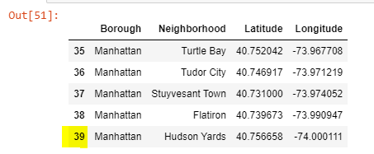
In order to pull in the venues for each neighborhood from Foursquare, one has to specify a radius around the latitude/longitude parameter. This is a subjective choise that influences the analysis as much as selecting # of K in K-means! I don’t think there’s a right answer, unfortunately. Some stakeholders don’t want to walk across the street to a better coffee shop, while others will travel 1 hour by public transport to have their favorite pastry (or perhaps to enjoy the journey and the anticipation).
Another reason the radius is very important is that if two neighborhood centroids are only 700 meters apart, then their venues will overlap and by definition they will end up in the same cluster.
I used DistanceMetric and pairwise to create a dataframe of Neighborhood-to-Neighborhood distances and saw that there are some neighborhoods that are actually quite close together.
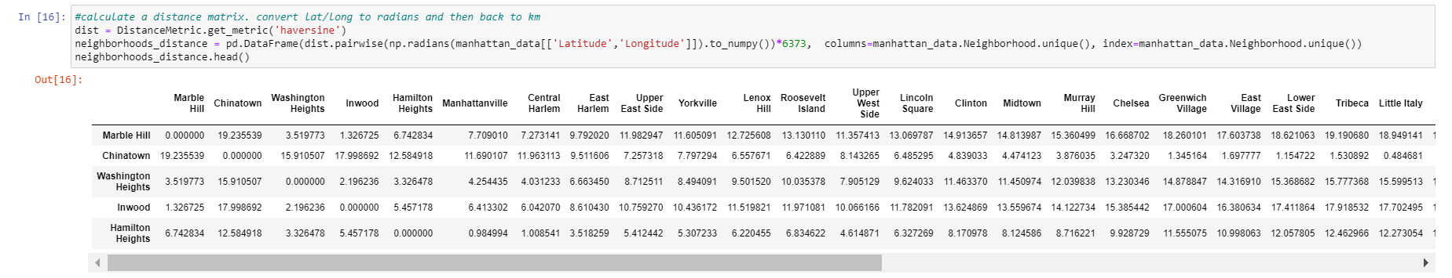
Of course, I also used folium to map the Menhattan Neighborhood centroids.
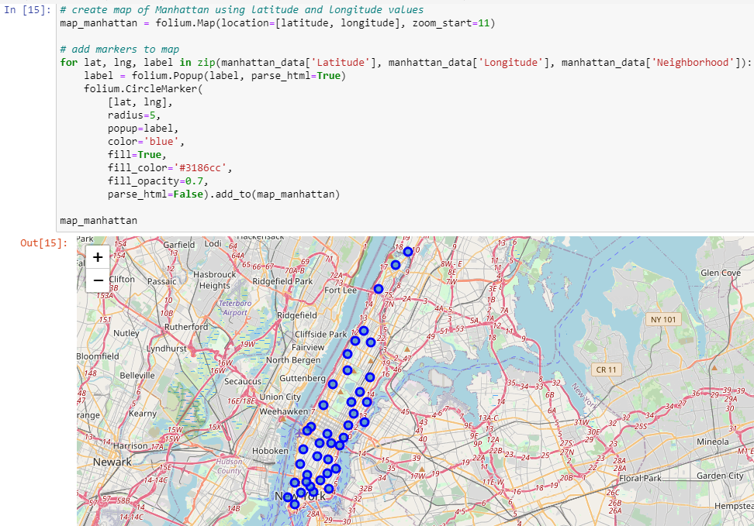
I ended up keeping the Foursquare radius=500 meters for consistency. After running the Foursquare API look and loading the data into a dataframe, we end up with 335 unique categories.
While for reasons described in the previous section I think the .mean() venue type (one-hot encoding) is not usefull, I still went with it, because my aim is to analyze Elbow clustering (in)consistency. (I did use .sum() to see if the results are more meaningful for some questions, but I didn’t find them to be dramatically more useful).
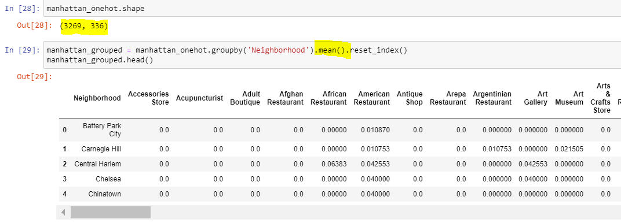
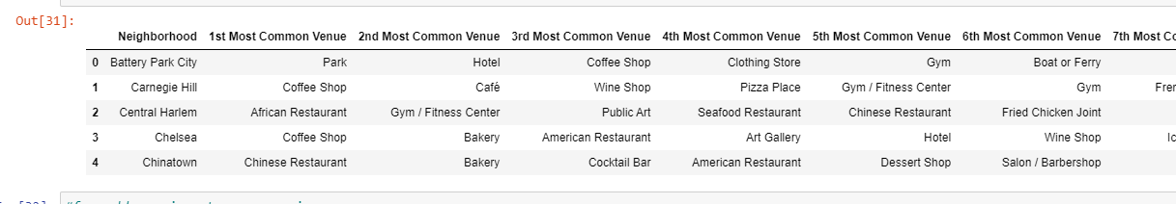
While for some very odd reason this was not illustrated in the course, KelbowVisualizer can and should be used to idenity the optimal k for clustering, like this:
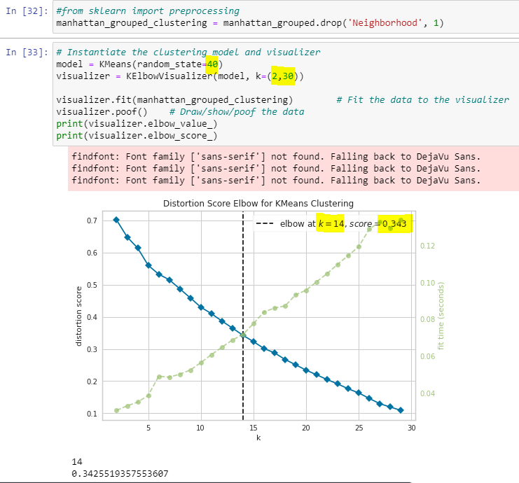
The inputs are:
1. k=(2,30) – meaning that it will cycle through these k values to find the elbow point.
2. Random_state=40 – if you don’t specify the random_state, you may not end up with the same elbow point and clustering results, each time you fit the data. Pretty important to know! You don’t have to use 40, of course.
The output graph (above) shows the distortion index on the left y-axis. Distortion is perhaps the most popular measure of cluster quality, but that doesn’t mean we have any understanding of what it means or whether the score is of sufficient quantity!
The elbow point is where there a FIRST drop in delta of Within-cluster-sum of Squared Errors (WSS). If you see curves without a clear elbow point, you may not have any clearcut clusters. Again, only as measured by the Within-cluster-sum of Squared Errors.
Distrotion index is the default metric Kelbow uses unless a different metric is spefied. We can use Silhouette and Calinski-Harabasz scores to identify optimal # of clusters using their particular metric methodology, just as easily!
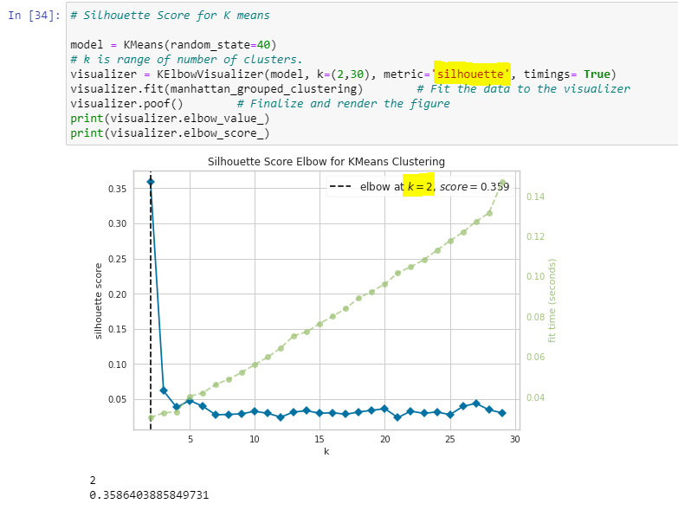
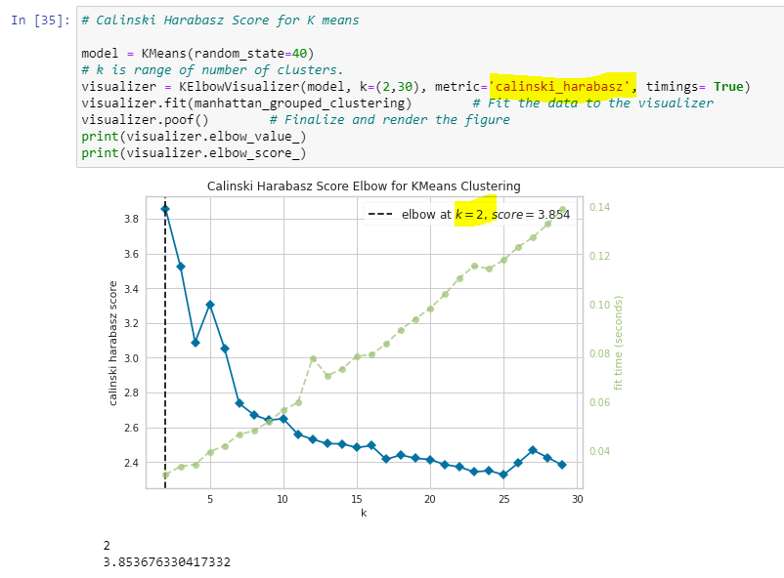

And hereing lies a major optimization problem! Silhouette and Calinski-Harabasz optimizations say that there are only 2 clusters in this dataframe, not 14!
Unlike distortion (SSE), silhouette and Calinski-Harabasz also compare tightness of clusters and tightness between clusters. With these metrics the optimal point is actually the PEAK of the scores, and not the TROUGH, as with distortion.
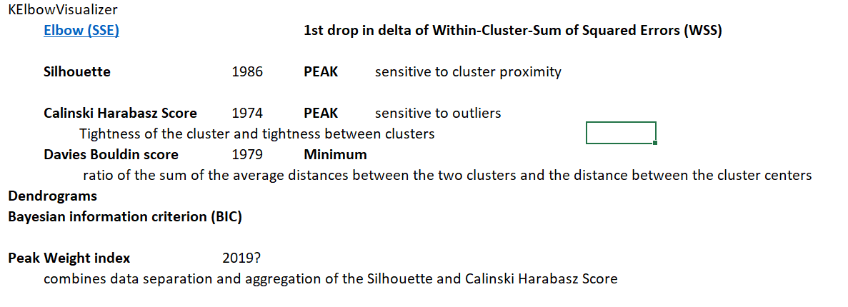
If you’d like to learn more about this, I highly recommend reading this blog.
“Cheat Sheet to Implementing 7 methods for selecting optimal number of clusters in python”
and this slide-desk: https://slidetodoc.com/clustering-methods-part-3-cluster-validation-pasi-frnti/
My Notebook includes Davis_bouldin Score visualization as well as Dendogram.
Also, Peak-Weight index aims to combine the best of Silhouette and Calinski-Harabasz metrics, because the first is sensitive to cluster proximity, while the second is sensitive to outliers. I was not able to easily find a ready to use function/library to calculate the Peak-Weight score. My understanding is that the paper suggesting this is relatively new.
How (in)consistent are the Elbows for Distortion, Silhouette, and Calinski-Harabasz?
This is the crux of what I wanted to analyze, while figuring out how to use ML on Foursquare data and whether it can be useful with a certain # of features.
First we sort the columns (venue types) so that the venue-types with the most data are on the left (Coffee shops, Italian Restaurants, etc…):
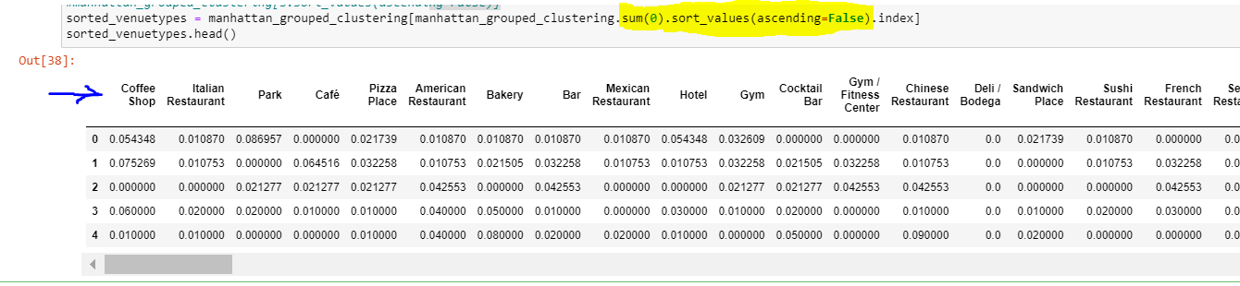
Then we create a For-loop to take between 4 and 19 of the most common venue types to calculate the Distortion, Silhouette, and Calinski-Harabasz scores and optimal K-values and chart the results below.
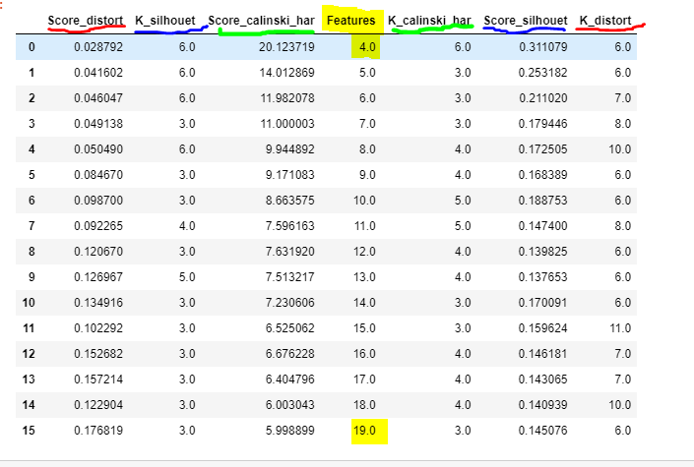
This graph illustrates the crux of the analysis – the “optimal” scores are very inconsistent!
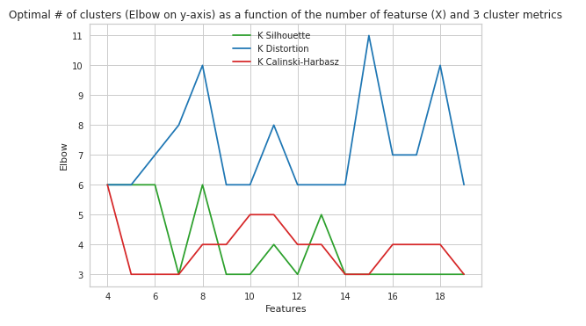
There seems to bit just a tad more consistency between Silhouette and Calinski-Harbasz, but the results are clearly almost never consistent! It just doesn’t make sense to cluster 40-50 neighborhoods on even as few as 5 venue-type features! (Let alone 300+ columns as we were instructed in the class!).
Perhaps the key point here is that with only 40-50 neighborhoods (rows), we have to ONLY use the 4 most non-null Venue types (features or columns) to have consistent clustering. Any more features and we either have too many zeroes for the additional feature OR similarity simply ceases to exist.
Again, business reality is much more complex than 4 of the most common features. Even if we were able to pull another 10 relevant business features like demographics and willingness to travel along with costs, we wouldn’t be able to model or predict what competitors will do or how the business/market environment will change in the future. This is probably the most important business analytics consideration not to forget.
Another key observation is that quality scores deteriorate dramatically as we add more features!
If we look at the Distortion Score only, it rises quite consistently as we add Features! The clusters become less and less representative of the points.
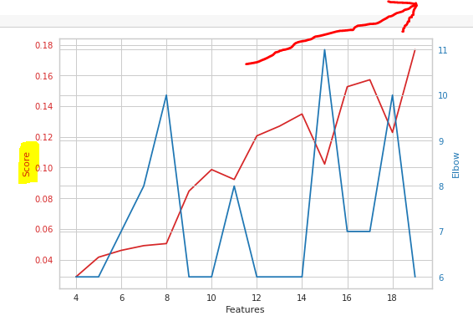

Silhouette and Calinski-Harabasz show the same patter of declining Cluster Similarity as we add features (remember high scores are good on these metrics, so falling score are bad).
Silhouette score (left) and Calinski-Harabasz (right) crash quite rapidly as features are added:
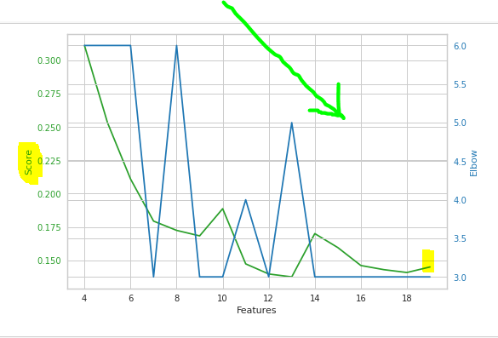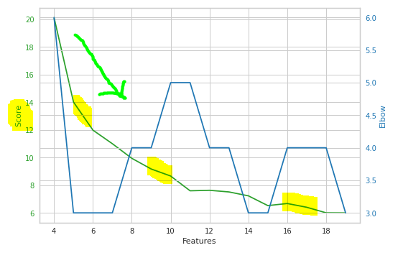

Since all 3 cluster quality metrics gave a consistent answer of 6 clusters, ONLY when we use 4 of the most common features (Coffee Shop, Italian Restaurant, Park, Café), we will actually apply the clustering and see what that looks like.
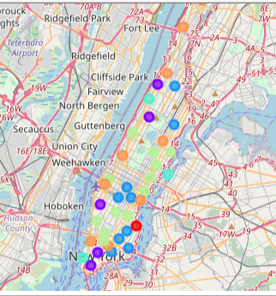
During the course, we were given code to analyze the clusters manually in a dataframe. However I don’t think that is the right way to visualize the clusters, because of differing density of venues between neighborhoods and because of course it doesn’t show only the 4 most common Venue Types.
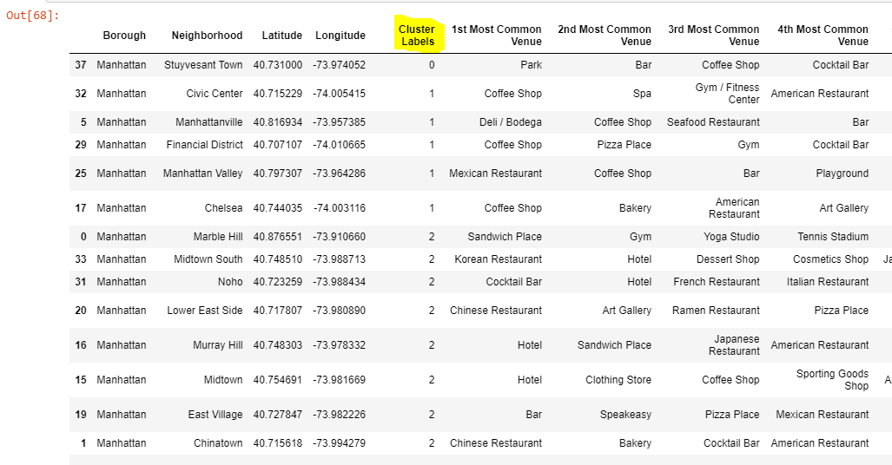
Instead, below is a much better way, using heatmap of venue density (mean), where it’s a tad easier to notice clusters with changing colors:
0: one-hood “cluster”, perhaps an outlier on it’s proximity to parks and the East River.
1: Coffee shops and some a few Italian restaurants.
2: Less coffee shops
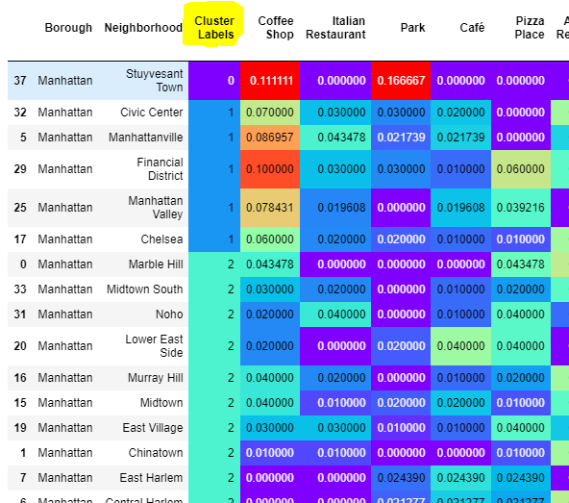
3: moderate coffee shops and close to parks.
4: moderate coffee shops and high Italian restaurans
5: high cafes
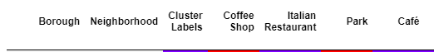
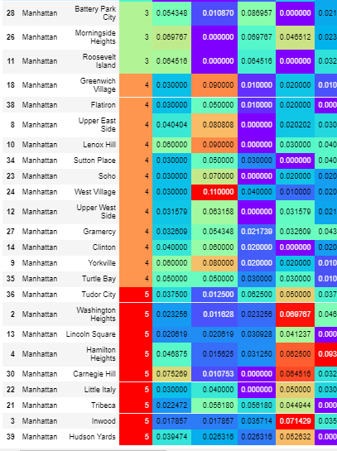
So there you go 40 neighborhoods, 4 features (using .mean()) organize into 6 clusters consistently using 3 different cluster quality metrics, BUT I think the key observation is that this is was hardly useful to teach without spending a lot more time on Feature Selection and Creation as well as the Analytic complexity of the real world, particularly social sciences and business domains.
Recommendation and Conculsion
This analysis was an attempt to outline the complexity of forming questions and feature selection instead of blindly throwing ML libraries at problems that are too complex, ambigous, and perhaps ill conceived.
I highly suggest aspiring data scientists to start with appreciating the complexity of different domains they’re trying to apply latest powerful DS tools to. And certainly not dabble in asking where to open a new restaurant for reasons eloquently put forth by Peter Thiel in Zero to One.
The following blogs were of tremendous value to me in supplementing what was NOT taught in this 10-class DS certification program.
1. The curse of dimensionality
https://towardsdatascience.com/k-nearest-neighbors-and-the-curse-of-dimensionality-e39d10a6105d
https://stats.stackexchange.com/questions/232500/how-do-i-know-my-k-means-clustering-algorithm-is-suffering-from-the-curse-of-dim
2. Data Science’s Most Misunderstood Hero: Why treating analytics like a second-class citizen will hurt you
Cassie Kozyrkov taught thousands of people at Google on decidions design and right and wrong ways to apply ML, DS, and Analytics. I find her writing and insights are simply the best out there.
https://www.linkedin.com/pulse/ultimate-guide-starting-ai-cassie-kozyrkov/
https://hackernoon.com/top-10-roles-for-your-data-science-team-e7f05d90d961
I suggest that the final course or two in this certification program spend some time on teach the following critically important topics:
1. The Curse of Dimensionality.
- what shape of data is necessary (10 or 100x rows as columns?)
- how null values affect meaningfullness and usability of ML
2. Feature and data selection
- Correlated features (columns)
- Important but missing features
Certainly start with physical data sets like clustering thousands of starts on a few features, instead of the business domain using irrelevant metric like % of venue types in a neighborhood.
3. Explain the compexities and impossibilities of “doing science” in social sciences and especially business. A data scientist that understands the latest DS tools and even statistics cannot apply said expertise, without an analytical mindset. Quite often ML is not the tool to apply and a lot more time should be spent simply analyzing the complexity of the problem(s).
4. Technical subjectivity of ML
- show how Kelbow can be looped to calculate at least 3 different cluster quality metrics and optimal # of clusters and how more often than not the results will NOT converge to the same “optimal” # of clusters.
Data science is an art and I hope my research and links above can help you become a better and more meticulous data scientist, while navigating around a minefield of problems.

